North Korea education
Background
Education in the North Korea is universal and state-funded schooling by the government. Children go through one year of kindergarten, four years of primary education, six years of secondary education, and then on to university. In 1988 the United Nations Educational, Scientific, and Cultural Organization (UNESCO) reported that North Korea had 35,000 preprimaries, 59,000 primaries, 111,000 secondary, 23,000 college and university, and 4,000 other postsecondary teachers (About).
In 1959 "state-financed universal education" was introduced in all schools; not only instruction and educational facilities, but also textbooks, uniforms, and room and board are provided to students without charge. By 1967 nine years of education became compulsory. In 1975 the compulsory eleven-year education system, which includes one year of preschool education and ten years of primary and secondary education, was implemented; that system remains in effect as of 1993 (North). In 2012 Chief Kim Jeong Eun has advocated that North Korea should expand its compulsory education from 11 years to 12 years.
How is North Korea doing at meeting the UN Global Initiative priorities
There are three priorities in this imitative, and the aims of it is to raise the political profile of education, strengthen the global movement to achieve quality education and generate additional and sufficient funding through sustained advocacy efforts.
The first priority is put every child in school. Here are two bars show the male and
female students out of primary school in 2009 in North Korea:

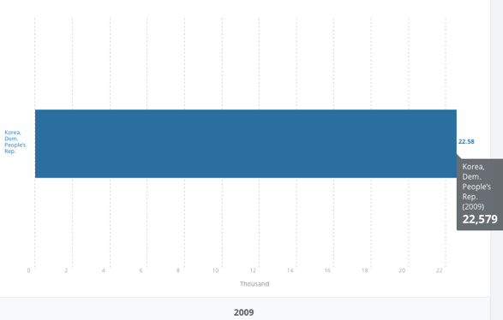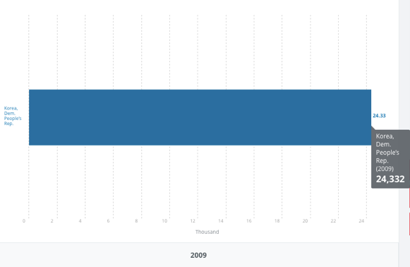
“Children out of school, primary, male and female” United Nations Educational, Scientific, and Cultural Organization (UNESCO) Institute for Statistics.
From http://data.worldbank.org/indicator/SE.PRM.UNER.MA?end=2009&locations=KP&start=2009&view=bar
According to the data from these two bars, there were total 46,911 kids are out of primary school in 2009. Although North Korea has the eleven years’ free education education, there are still lots of families won’t let their kids go to school. In North Korea, most family do agriculture for living, they choose to let their kids help family in fields or go to work instead of let them go to school, this is what we called child labor. This is because of the lack of information. Since North Korea has the seclusion policy, people don’t have ways to connect with outside world, they can not realize how important it is for their kids to go to school, to receive the education. And because their last generation also did not send them to school, they also choose to let their kids to not get education. So even though North Korea provide free education, because of the policy, there are still many kids are out of school.
The second priority is improving the quality of learning. In North Korea, students are taught the communist ideology and also the greatness of their leaders such as Kim Jong II and Kim II Sung through education. The subjects taught are also directed towards science and technology so as to enable students to be the future technicians, scientists, and workers that the government can rely on to achieve the country’s goals. Korean education is made up of kyoyuk which is basically technical skills and scientific knowledge (The). The biggest problem is North Korea need to improve is lack of learning materials. North Korea’s policy is really a big issue for education. The government would not publish any of outside word’s news, people in North Korea can not use the internet to connect with other people all over the word. The government use text books to brainwashes children from an early age to believe Kims as godlike leaders (North). This won’t help kids with their study, they need to learn new things, advanced knowledge, foreigner languages, etc. They can not just stay in North Korea; they need to see the new world. But due to the policy, kids in North Korea have limited things to learn and it is really hard to improve the quality of learning in this country.
The last one is foster global citizenship. According to UN requirements this priority needs teachers’ effort to help every student to build correct values of peace, human rights, respect, cultural diversity and justice. But in North Korea, the scarcity of teachers’ number is a big problem. Lets’ see a map of North Korea teacher average number in primary school in 2009.
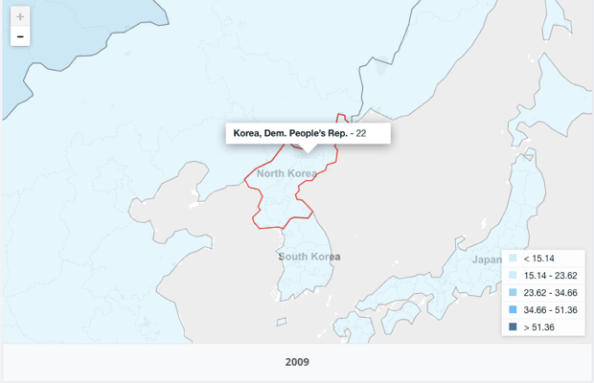
“Teacher ratio in primary education” United Nations Educational, Scientific, and Cultural Organization (UNESCO) Institute for Statistics. From http://data.worldbank.org/indicator/SE.PRM.ENRL.TC.ZS?end=2014&locations=KP&start=2014&view=bar
This map shows that the average number of teachers in each primary is 22. The primary school has four grades, so for each grade, there are only 5.5 teachers to teach kids all subject and take care of them. Except teach kids the academic content, teachers also need to look after kids in school, help them build right values. The problem is small number of teacher and large number of students. Teachers can not take care of every one, their missions are quite heavy and hard to achievement. In this situation, the quantity of teaching and learning decrease a lot and can not be easy to improve. Many teachers lack the training, confidence and classroom resources to meet these challenges without support and instruction. Although North Korea’s government claims that they will do some changes, if they do not solve this problem fundamentally, it is very hard for them to achieve those goals.
Works Citied
About this Collection - Country Studies. (n.d.). Retrieved March 29, 2017, from
https://www.loc.gov/collections/country-studies/about-this-collection/
Global citizenship | United Nations Educational, Scientific and Cultural Organization.
(n.d.). Retrieved March 30, 2017, from http://www.unesco.org/new/en/gefi/priorities/global-citizenship
North Korea - EDUCATION. (n.d.). Retrieved March 29, 2017, from
http://countrystudies.us/north-korea/42.htm
The Education System in North Korea. (n.d.). Retrieved March 30, 2017, from
http://www.studycountry.com/guide/KP-education.htm

